

**LA PRIMAVERA**

1. **RECORTAR LOS NOMBRES Y PEGAR EN LAS IMÁGENES.**

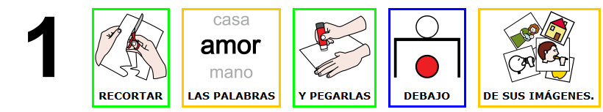

1. **ESCRIBIR LOS NOMBRES EN LAS IMÁGENES.**

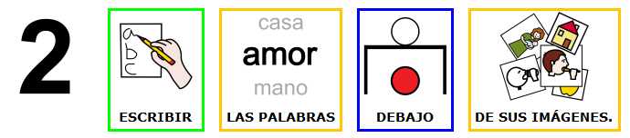

1. **RECORTAR LAS IMÁGENES, PEGAR EN EL CUADERNO Y ESCRIBIR SU NOMBRE.**

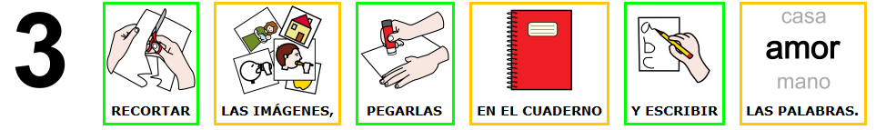

|  |  |  |
| --- | --- | --- |
|  |  |  |
|  |  |  |
|  |  |  |
|  |  |  |
|  |  |  |
|  |  |  |
|  |  |  |
|  |  |  |

|  |  |  |
| --- | --- | --- |
|  |  |  |
|  |  |  |
|  |  |  |
|  |  |  |
|  |  |  |
|  |  |  |
|  |  |  |
|  |  |  |
|  |  |  |
|  |  |  |
|  |  |  |
|  |  |  |
|  |  |  |
|  |  |  |
|  |  |  |
|  |  |  |
|  |  |  |
|  |  |  |
|  |  |  |
|  |  |  |
|  |  |  |
|  |  |  |
|  |  |  |
|  |  |  |

1. **RECORTA Y PEGA EN LAS IMÁGENES ANTERIORES**

|  |  |  |
| --- | --- | --- |
| **PRIMAVERA** | **LLUVIA** | **SOL** |
| **VIENTO** | **NUBLADO** | **CAMISETA DE MANGA LARGA** |
| **CAMISETA DE MANGA CORTA** | **PAÑUELO** | **SUDADERA** |
| **CAZADORA** | **CHUBASQUERO** | **PRIMAVERA** |

|  |  |  |
| --- | --- | --- |
| **FRESA** | **KIWI** | **LIMÓN** |
| **CEREZAS** | **CIRUELA** | **ESPÁRRAGOS** |
| **GUISANTES** | **ZANAHORIA** | **AGUACATE** |
| **ROSQUILLA** | **TORRIJA** | **HUEVO DE PASCUA** |

1. **RECORTA Y PEGA EN LAS IMÁGENES ANTERIORES**

|  |  |  |
| --- | --- | --- |
| **HOJA** | **ÁRBOL** | **ALMENDRO**  **EN FLOR** |
| **HIERBA** | **ARROYO** | **FLOR** |
| **TALLO** | **RAÍZ** | **AMAPOLA** |
| **MARGARITA** | **GIRASOL** | **GERANIO** |

|  |  |  |
| --- | --- | --- |
| **INSECTOS** | **SALTAMONTES** | **MARIQUITA** |
| **MOSCA** | **ABEJA** | **MARIPOSA** |
| **PATO** | **GOLONDRINA** | **CIGÜEÑA** |
| **SEMANA SANTA** | **DÍA DEL LIBRO** | **DÍA DEL TRABAJO** |

1. **ESCRIBE EL NOMBRE DE LAS IMÁGENES**

|  |  |  |
| --- | --- | --- |
|  |  |  |
|  |  |  |
|  |  |  |
|  |  |  |
|  |  |  |
|  |  |  |
|  |  |  |
|  |  |  |
|  |  |  |
|  |  |  |
|  |  |  |
|  |  |  |
|  |  |  |
|  |  |  |
|  |  |  |
|  |  |  |
|  |  |  |
|  |  |  |
|  |  |  |
|  |  |  |
|  |  |  |
|  |  |  |
|  |  |  |
|  |  |  |
|  |  |  |
|  |  |  |
|  |  |  |
|  |  |  |
|  |  |  |
|  |  |  |
|  |  |  |
|  |  |  |

1. **RECORTA LAS IMÁGENES, PÉGALAS EN TU CUADERNO Y ESCRIBE SU NOMBRE**

|  |  |  |
| --- | --- | --- |
|  |  |  |
|  |  |  |
|  |  |  |
|  |  |  |
|  |  |  |
|  |  |  |
|  |  |  |
|  |  |  |
|  |  |  |
|  |  |  |
|  |  |  |
|  |  |  |
|  |  |  |
|  |  |  |
|  |  |  |
|  |  |  |