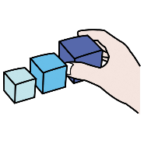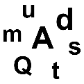

ORDENA LAS LETRAS



|  |  |  |  |  |  |  |  |
| --- | --- | --- | --- | --- | --- | --- | --- |
|  | | | | | | |  |
|  |  |  |  |  |  |  |  |

|  |  |  |  |  |
| --- | --- | --- | --- | --- |
|  | | | | |
|  |  |  |  |  |

|  |  |  |  |
| --- | --- | --- | --- |
|  | | | |
|  |  |  |  |

|  |  |  |  |
| --- | --- | --- | --- |
|  | | | |
|  |  |  |  |

|  |  |  |  |
| --- | --- | --- | --- |
|  | | | |
|  |  |  |  |

|  |  |  |  |
| --- | --- | --- | --- |
|  | | | |
|  |  |  |  |

|  |  |  |  |  |  |  |  |
| --- | --- | --- | --- | --- | --- | --- | --- |
| CARAMELO | EducaSAAC | | | | | | |  |
|  |  |  |  |  |  |  |  |

|  |  |  |  |
| --- | --- | --- | --- |
| **LEÓN (ANIMAL) | EducaSAAC** | | | |
|  |  |  |  |