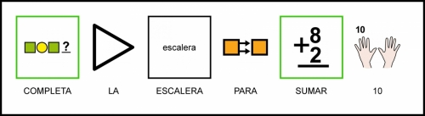

 | + |  | = | 10
 | + |  | = | 10
 | + |  | = | 10
 | + |  | = | 10
 | + |  | = | 10
 | + |  | = | 10
 | + |  | = | 10
 | + |  | = | 10
 | + |  | = | 10
10

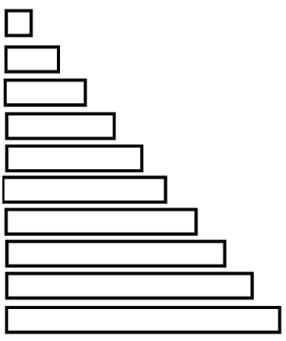
Autor pictogramas: Sergio Palao Procedencia: ARASAAC http://catedu.es/arasaac/ Licencia: CC (BY-NC-SA)
Autora: Amaya Padilla Collado http://www.samogaespecial.blogspot.com/

